# **MEET Y1 Unit 6 Lab 1: Loops!**

## **While Loops and Graphics**

1. Last week you learned how to draw images with Turtle. Now let’s make more complex shapes and patterns using "while" loops.

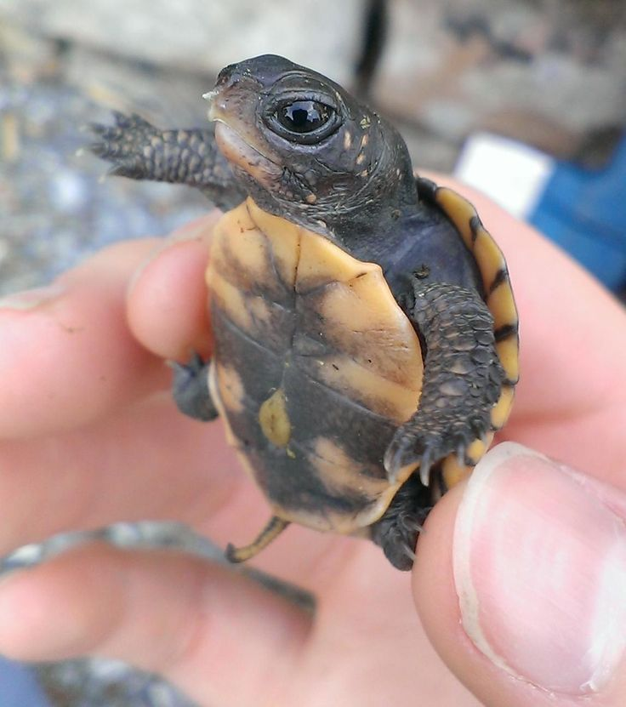

Make a new file called maths_plots.py and copy the code below:

|  |
| --- |
| **import** turtle  x = 0  **while** x<300:  y = x**2/300 #x**2 is the same as x*x  turtle.goto(x, y)  x = x + 1  turtle.mainloop() |

We made a graph of a math function!

How many times does the loop repeat? _____300__________

Now change the last line to x = x + 100

What do you think will happen to the graph?

________________________________________he will be sharp______________________________

Now how many times does the loop repeat? ___3_____________

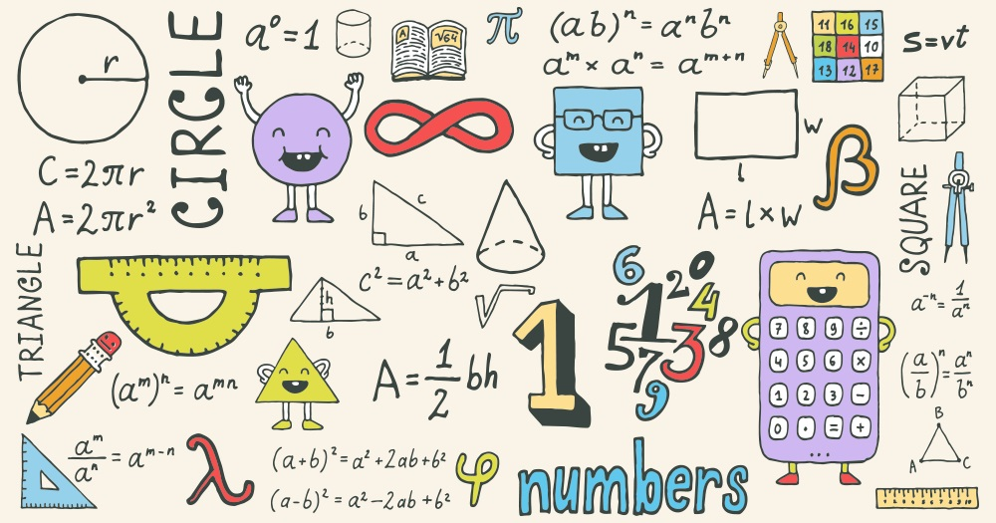

## For Loops

2. Make a new file in idle and call it "**turtleshapes.py**". Let’s use a for loop to draw something! Try this:

|  |
| --- |
|  |

We drew a pentagon!!!

How many times does the loop repeat? ______5_________

What does the function **range**(num_pts) do? ____says how many times the loop goes_______

Try increasing the number of sides to your shape.



## **FIZZBUZZ!**

**We want a list of numbers from 1 to n. If a number is divisible by 3, instead of adding the number, add "fizz"!**

|  |
| --- |
|  |

[**Now on your own complete the FizzBuzz challenge on codingbat!**](https://codingbat.com/prob/p235146)

**If a number is divisible by 5, instead of appending the number, append "buzz" to the list!**

**If it is divisible by 5 and 3, append "fizzbuzz"!**

### Bonus 1:

Using turtle and an infinite loop (hint “while True:”) create a cool design or screen saver!

Here is some example code to get your creative juices flowing!

|  |
| --- |
| import turtle  turtle.tracer(1)  rounds = 10  size = 10  mike = turtle.clone()  steve = turtle.clone()  turtle.bgcolor("white")  turtle.hideturtle()  mike.color("gold")  steve.color("blue")  steve.goto(5,5)  while True:  mike.forward(size)  mike.left(90)  steve.forward(-size)  steve.left(-90)  size += 10  turtle.mainloop() |

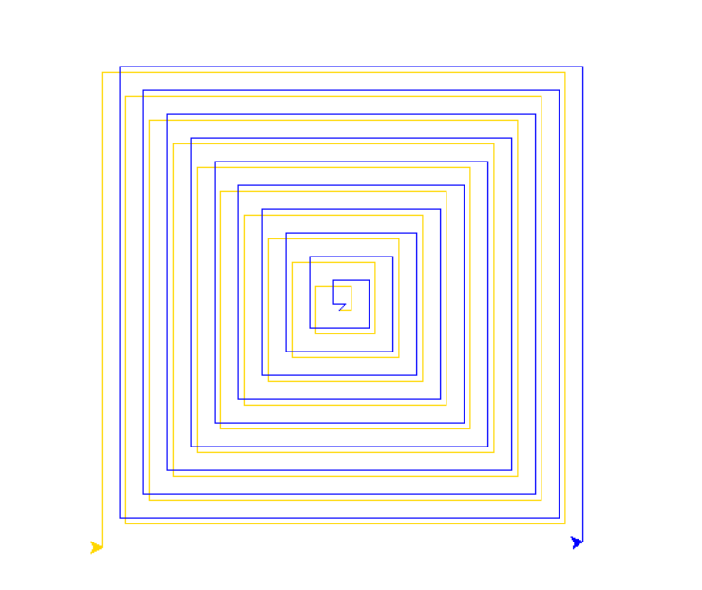

### Bonus 2:

Looking for an extra coding challenge? Try codingbat.

[String challenge problems with loops](https://codingbat.com/python/String-2)

[List challenge problems with loops](https://codingbat.com/python/List-2)

Before the end of class:

Save your work using endlab!!

Challenge problems!

1. What time of day will it be 100,000 minutes past noon today?

*Hint: you can use a while loop or the % operator for this problem. See if you can solve it both ways.*

1. Write a program that prints how many 20, 10, 5, 2, and 1-shekel notes/coins I should give to someone if I owe them ₪58.

Keep in mind that I want to give them the smallest number of notes/coins possible. So don’t just print “58 1-shekel coins” !

1. How many prime numbers are there between 1 and 1000? (Do not google this, except to check your answer.)

*Hint: first solve a simpler problem-- how can you know if a number is prime?*

1. Write a program that draws a picture like this one:

